Template Annual Resident Education Email

Annual notification and education to tenants is required by State law SB 1383. In order to help you make the most of your property's waste services—and divert as much waste as possible from California landfills.

Please find an example template email below to educate your residents: The highlighted words indicate portions of the template that should be changed before distribution. Add specific about recycling and composting programs at your property.

Dear Resident,
California State law, SB 1383, aims to keep food and other compostable materials (“organics”) out of landfills to reduce emissions that contribute to climate change. To comply with the new law, we are providing information on the recycling and compost program at [insert building address or property name]. Most of the discarded materials at our location are recyclable or compostable and residents are required to sort those materials into the correct bins. Recycling and composting helps our environment by conserving natural resources and reducing energy use, pollution, and greenhouse gas emissions.
Our goal is to make recycling and composting easy for you. Here is how the programs work.

Where are the [Services] bins located at [Property]?

[Property] has [#] indoor collection areas and [#] outdoor collection areas. Residents can access these areas by [method of access, noting security codes or lock mechanisms that could pose a barrier to entry.]
- Include linked or embedded images of property maps with collection areas marked. Note: these images may not load for all recipients, so make sure that you include at least one additional option!
- Provide text-based information about where residents can find collection areas.
- Provide URL links to online maps that include the location(s) of collection areas at the property

What materials go into each bin?

It is important to sort materials into the right containers to ensure that recoverable resources are actually recovered—and to keep our service costs low! Amador Valley Industries provides handy sorting guides that can help keep contamination low. Below is an overview of the types of materials that belong in each bin.

[Select the photo version or text version below]

Option 1: Photos

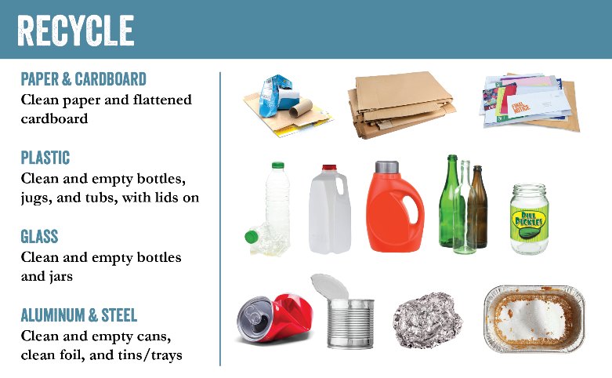 | 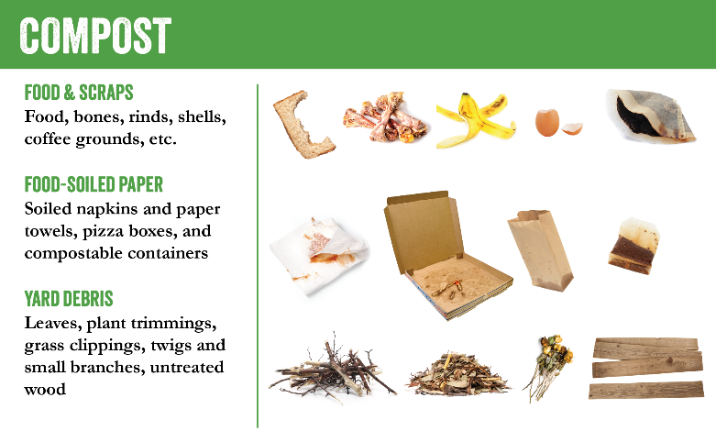 | 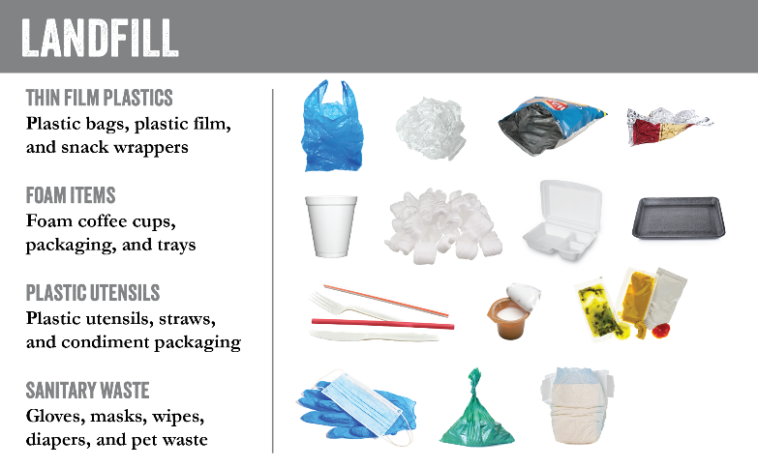
Option 2: Text
RECYCLE | COMPOST | LANDFILL
The BLUE recycle bin focuses on capturing materials to be reused to create new products. This stream is meant to capture:  Mixed Rigid Plastics  - Beverage bottles  - Plastic jugs (milk jugs, detergent containers)  - Plastic tubs (butter or yogurt tubs with lids)  Glass  - Glass bottles  - Glass jars  Metal  - Aluminum cans  - Tin Cans  - Clean foil  - Clean aluminum trays  - Other small pieces of scrap metals  Paper  - Clean paper  - Clean, flattened cardboard  Containers should be empty, clean, and dry but it's okay to wipe, scrape, or rinse food residue out of containers (such as cans, peanut butter, jelly, mayo jars), just as long as there is no residual food waste. | The GREEN compost bin is used to capture materials that can be used to create nutrient rich compost for uses in agriculture to backyard gardening. This stream is meant to capture:  Food and Scraps  - Food  - Bones  - Rinds and peels  - Shells  - Coffee and tea grounds  Food-Soiled Paper  - Soiled napkins  - Paper towels  - Pizza boxes and other waxed cardboard  - Compostable take-out containers  Yard Debris  - Leaves  - Plant trimmings  - Grass clippings  - Small branches  - Untreated wood  Food should be composted loose (not in packaging) and labels should be removed from peels and rinds. | The GRAY landfill bin is meant to capture materials that cannot be recycled or composted, such as:  Thin Film Plastics  - Plastic bags  - Plastic film  - Snack wrappers  Foam Items  - Foam coffee cups  - Foam takeaway containers  - Foam packaging  Plastic Utensils  - Utensils  - Plastic straws  - Condiment packaging  Sanitary Waste  - Gloves  - Masks  - Wipes  - Diapers  - Pet waste  Hazardous items such as electronics, fuel containers, cleaning materials, and bulky items cannot be  accepted. Check Dublin's online sorting guide if in  doubt!

When are bins emptied?

At [Property], bins are emptied each [WeekDay] except for major holidays and rare service interruptions. If you notice that a bin is overfilled, or if a collection area is cluttered or unsanitary, please let [PropertyManager] know as soon as possible so that we can request additional service or maintenance.
- Provide link to Property-specific maintenance request / reporting form (if applicable) or link to direct email the Property Manager.
Why should I recycle and compost?

Properly sorting and disposing of your organics and recyclables not only helps to fight climate change, but is also now the law in California. California State law (SB 1383) went into effect January 1, 2022 and requires businesses to keep compostable and recyclable materials out of California’s landfills. This means that recyclable and organic materials may no longer be placed in your garbage.

How can I find out more?
- Learn more about [Property]'s waste reduction and sustainability efforts by reaching out to [PropertyManager] or visiting [PropertyWebsite].
- Learn more about proper sorting in City of Dublin by visiting https://resource.stopwaste.org/curbside/dublin.
- Learn more about safe and proper hazardous waste disposal by visiting: https://www.stopwaste.org/at-home/household-hazardous-waste
Learn more about the link between waste reduction and climate change by visiting https://calrecycle.ca.gov/organics/slcp/.

