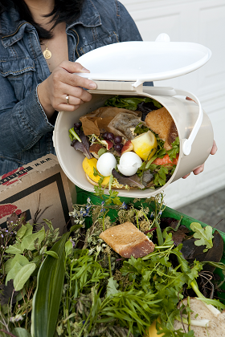
Hello! We stopped by today to share some exciting information about your property’s recycling and composting program. Sorry we missed you!

We handed-out free recycling tote bags and kitchen pails to help residents take food scraps from the kitchen to the outside organics cart. This brochure explains what goes into both the recycling and organics bins.

If you would like your free recycling tote bag and/or kitchen compost pail for food scraps, or have any questions about recycling or composting, please contact: [PROPERTY MANAGER], [EMAIL], [PHONE]

__________________________________________________________________.

Hello! We stopped by today to share some exciting information about your property’s recycling and composting program. Sorry we missed you!

We handed-out free recycling tote bags and kitchen pails to help residents take food scraps from the kitchen to the outside organics cart. This brochure explains what goes into both the recycling and organics bins.

If you would like your free recycling tote bag and/or kitchen compost pail for food scraps, or have any questions about recycling or composting, please contact: [PROPERTY MANAGER], [EMAIL], [PHONE]

__________________________________________________________________.

Hello! We stopped by today to share some exciting information about your property’s recycling and composting program. Sorry we missed you!

We handed-out free recycling tote bags and kitchen pails to help residents take food scraps from the kitchen to the outside organics cart. This brochure explains what goes into both the recycling and organics bins.

If you would like your free recycling tote bag and/or kitchen compost pail for food scraps, or have any questions about recycling or composting, please contact: [PROPERTY MANAGER], [EMAIL], [PHONE]

__________________________________________________________________.

