Template Memo to Tenants: Educating about the new or expanded Recycling Program

[The highlighted words indicate portions of the template that should be changed before distribution. Add specifics about recycling and/or composting programs at your property, frequency of collection, and other program information. With additional minor modifications, you may be able to use this to provide information to tenants upon move-in or move-out.]
Date: [insert date]

To: [Building Tenants]

From: [insert name, title, i.e., Property Manager]

Re: Recycling [and Composting] Program

California State law, SB 1383, aims to keep food and other compostable materials (“organics”) out of landfills to reduce emissions that contribute to climate change. To comply with the new law, we are [starting a new or improving the] recycling and compost program at [insert building address or company name]. Most of the discarded materials at our location are recyclable or compostable and residents are now required to sort those materials into the correct bins. Recycling and composting helps our environment by conserving natural resources and reducing energy use, pollution, and greenhouse gas emissions.
Our goal is to make recycling and composting easy for you. Here is how the program will work:

In-home Collection:

- Create a 3-bin system at home, one for garbage, one for compost, and one for recyclables.
- Place your recyclables loosely in your bin without a liner.
- Use a bowl or kitchen pail to collect food scraps. Line your compost pail with a paper bag, paper towels, or newspaper. NO GREEN OR PLASTIC BAGS. Take your compost out to the organics/food waste cart as needed to prevent smells and pests.

AVI offers complimentary recycling totes and kitchen compost pails to make in-home collection easier.

- To request these materials , please contact your property manager.

Central Collection:
Indicate specifically where the AVI-serviced containers are located. Use the text below as a template.

Containers for the collection of garbage, recyclables and compostables are in the [parking garage, garbage enclosures, etc.]. Please keep materials separated between the three streams. The containers will be emptied [daily, or frequency by type of container].

What Goes in Each Container?

Recyclables
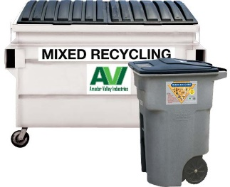
All clean office paper, glass bottles and jars, aluminum foil and cans, steel/tin cans, and plastic containers belong in the [blue] containers.

Where does it go? All recyclable material is sent to processing facilities for sorting. The materials are then sold to recyclers and made into new products.

Compostables
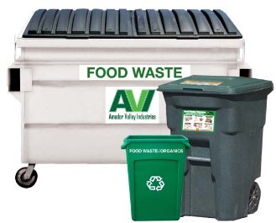
Most of the material that used to go in the garbage, can now be put in the [green] organics containers. This includes left-over food, paper take-out containers, paper coffee cups, used napkins, used napkins, used paper towels, and soiled paper.

Where does it go? All compostable material is sent to a composting facility where it is turned into compost, a soil amendment for local farms, landscapes, and gardens.

Garbage
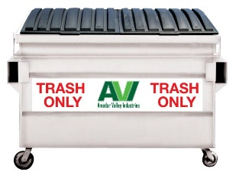
Very few items belong in the garbage. Items that should be put in the garbage include: styrofoam, candy wrappers, chip bags, and cartons (juice boxes/shelf-stable liquid cartons/Tetrapaks).

Where does it go? Any material put in the garbage is sent to landfill.

We’re proud to contribute to the greening for our residents and greater community. We need everyone’s participation for this program to be successful!

Our target start date will be [insert date]. Watch for additional communication as the date approaches. Please feel free to contact [insert contact name, phone number and/or email address] with any questions.


Unsure about what goes where? Use StopWaste’s Re:Source Tool to look up the material!

